**ExNo:4 JAVA PROGRAMMING LABORATORY**

**Develop an java application for customer – account using Single inheritance**

import java.util.*;

class customer

{

int id;

String name,gender;

Scanner sc=new Scanner(System.in);

void getCustomerInfo()

{

System.out.println("Enter the customer's name,id and gender");

name=sc.next();

id=sc.nextInt();

gender=sc.next();

}

void printCustomerInfo()

{

System.out.print("Customer name: "+name+"\nCustomer id: "+id+"\nGender: "+gender);

}

}

class account extends customer

{

int accno,balance;

Scanner sc=new Scanner(System.in);

void getAccdetails()

{

System.out.println("Enter Account number and balance:");

accno=sc.nextInt();

balance=sc.nextInt();

}

void deposit(int b)

{

balance=balance+b;

System.out.println("Your Balance= "+balance);

}

void withdraw(int bb)

{

if(bb>balance || balance<100)

{

System.out.println("You don't have minimum balance");

}

else

{

balance=balance-bb;

System.out.println("Your balance is: "+balance);

}

}

int checkBalance()

{

System.out.println("Your Balance is: "+balance);

return balance;

}

public static void main(String args[])

{

account ac=new account();

ac.getCustomerInfo();

ac.getAccdetails();

Scanner sc=new Scanner(System.in);

int ch,c,b1,b2;

do

{

System.out.println("Enter you choice:\n1.Deposit\n2.Withdraw\n3.Check Balance");

ch=sc.nextInt();

switch(ch)

{

case 1:

System.out.println("------DEPOSIT------");

ac.printCustomerInfo();

System.out.println("\nEnter your deposit amount: ");

b1=sc.nextInt();

ac.deposit(b1);

break;

case 2:

System.out.println("-----Withdraw------");

ac.printCustomerInfo();

System.out.println("\nEnter your Withdrawal amount: ");

b2=sc.nextInt();

ac.withdraw(b2);

break;

case 3:

ac.checkBalance();

break;

default:

System.out.println("Enter right choice");

break;

}

System.out.println("Press 0 to continue...");

c=sc.nextInt();

}while(c==0);

}

}

**OUTPUT:** 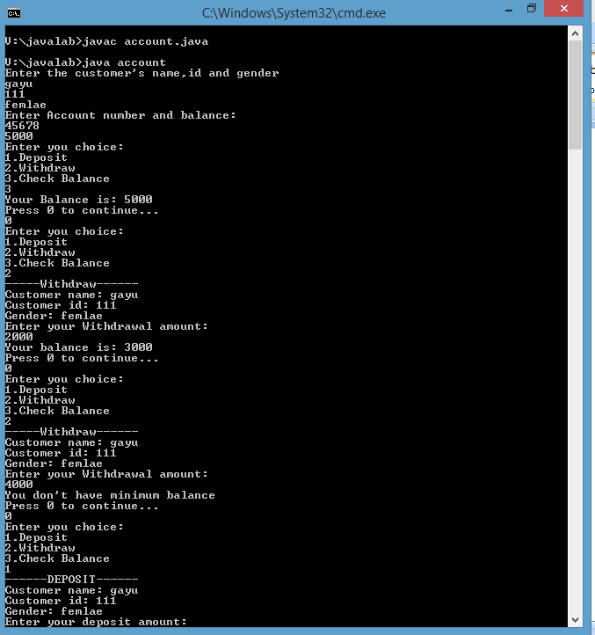

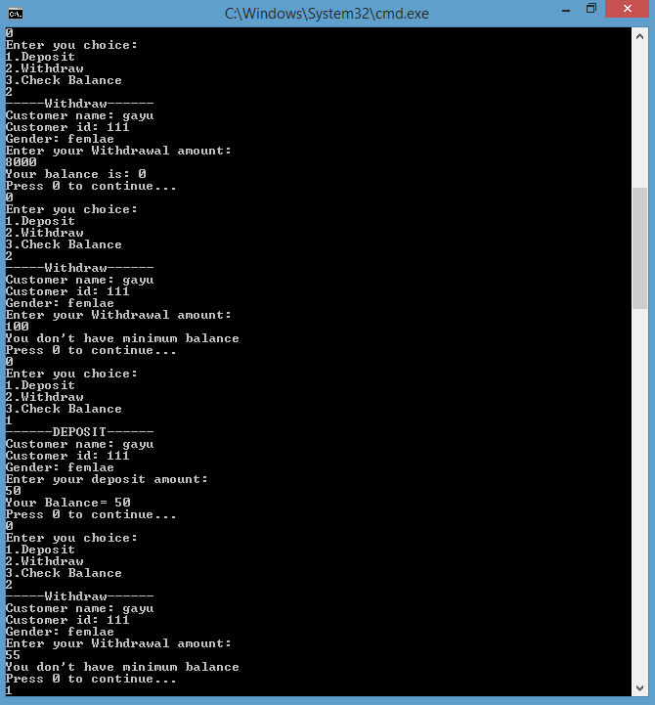

|  |
| --- |
| **M.GAYATHRI**  **CSE-'A'**  **1712022** |